FRANCHISE
STATIONERYBAZAAR.COM


Business Overview:
Choosing to open a stationery store could well prove to become one of the smartest business decisions you make. This is a time tested business idea, and with it you can make great profits selling products that everyone needs. Through your stationery store you will typically sell usual stationery items such as pens, pencils, folders and paper. However, you’ll certainly not be limited to only selling typical products such as these, as you’ll have a great deal of freedom to offer a variety of other products. Most stationery stores also offer cards (birthday cards, Christmas cards, thank you cards, etc.) and many other products like calendars, photo albums, diaries, desk clocks, ink cartridges, gift wrapping, and much more. Added to the freedom you’ll have in choosing which products to offer, you can also choose whether you want to get creative and build your own unique stationery store. No special qualifications or experience are required to open a stationery store and build it into a profitable business. Desire, creativity and commitment are all you really need to succeed with this business idea.
A Day in the Life of a Stationery Store Business Owner:
As a stationery store business owner, you will arrive at your store about 15 minutes early to ensure everything is in order, before opening your doors for business around 9 a.m. Throughout the day people will enter your store to purchase stationery items, and you will serve them. You may also provide assistance to customers and help them either with locating the specific stationery products that they are looking for, or to choose memorable cards for special occasions (birthdays, weddings etc.). At around 8 p.m., you would close your store, ensuring that everything is clean and tidy and ready for business again the next day. Alternatively, you can hire staff to serve customers and to open and close your store for you. In this case a typical day would consist of ensuring the smooth running of your store by overseeing your store and making the high-level decisions. Other typical daily activities would include ordering new stock whenever supplies run low and taking requests from customers for special orders they may want.

About Your Customers:
Your customers will be people looking to purchase stationery. They are most likely to be business people or students looking for stationery for home or for the office. Many of your customers will also visit your store looking for memorable birthday cards to give to friends or relatives for upcoming special occasions such as birthdays or weddings.
The Good:
- It’s a truly “evergreen” market – people will always need stationery products and cards.
- You’ll have a great deal of freedom to choose additional types of products to offer (such as birthday cards, diaries, photo albums, etc.).
- No special qualifications or experience is needed.
The Bad:
- It may take a while for you to see profits as the initial start-up costs are fairly high.
- You’ll need to work hard and be creative to make your stationery business stand out, as you will likely be up against well-established competition in your area.
FRACHISE DETAILS
We have been getting several enquiries from various parts of India for starting StationeryBazaar.com retail outlets. We have categorized the potential cities and towns in India into three levels and fixed area and investment accordingly.
- Showroom area 200 to 250 sft – Investment upto Rs. 5 to 7 lakh
- Showroom area 500 sft and above – Investment Rs 10 lakh to 15 lakh
- Showroom area 1000 sft and above – Investment Rs. 20 lakh and above
You can also register as supplier working from an office and a warehouse. For this you need to only invest in stock from us.

The above investment includes cost of:
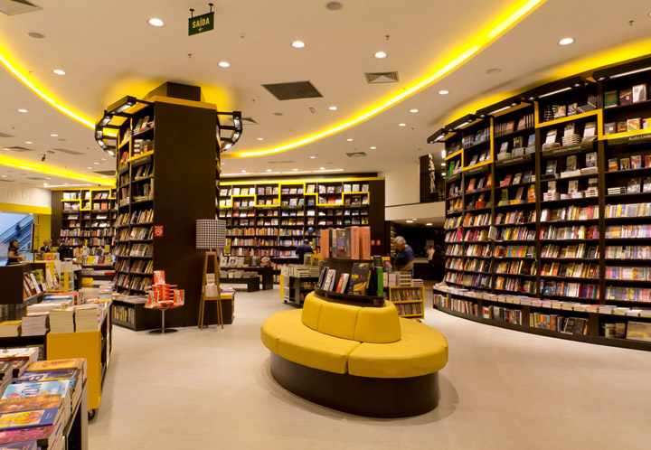
- Interiors
- Stocks
- Telephone, fax, computer, printer, bar-code reader etc.,
- Initial stationery – billing receipts etc., and packing materials – covers
- Glow sign board
- Security deposit
- The Franchisee should have a showroom, either own or on long lease, with a minimum of 200 sft carpet area. Deposits and any other costs involved will have to be borne by the franchisee. Telephone and electricity should be installed by the franchisee.
Architects and contractors appointed by StationeryBazaar,com would do interiors, with complete furniture and fixture. In case the franchisee wants to get the interiors done on his own, he/she is free to do so. BUT, it has to be done according to the specifications and designs provided by us. Our architects for providing the service would collect a nominal charge.

This is how the total investment in the shop would be –

1 | Interiors - About 150 sft showroom space and 100-sft storage/godown spaces. (Incase extra showroom space is created an amount of Rs 1000/sft would be charged extra) | Rs. 1.50 lakh
2 | Stocks | Rs. 3.00 lakh
3 | Telephone, computer, printer, bar-code reader CC camera(s), internet-enabled online billing and monitoring system etc., one Glow sign board | Rs. 1.00 lakh
4 | Initial stationery – billing receipts etc., and packing materials – covers  (To be provided by the company free of charge for the first time) | Free
5 | One time Non-refundable fees (for 5 years) | Rs. 0.50 lakh
 | TOTAL | Rs. 6.00 lakh

For Larger Stores, our franchise team will provide more detailed break up of cost.

Assistance Provided
StationeryBazaar.com, besides proving the brand name and high level and goodwill and reputation built in the market, provides the following to the Franchisees.
- Interior design, display and shop lay-out assistance
- Stocks – fully packed with logo and bar code sticker
- Billing soft-ware
- Marketing strategy and Country-wide publicity in media
- Training and Guidance to the franchise owner and selected employees
- Assistance in selection of employees
- Packing and billing material at nominal cost
- Complete hand-holding and support service
- Networking with bankers

Conditions
Franchisee will enter into an agreement with StationeryBazaar.com upon satisfactory fulfillment of the Franchise requirements of space and investment. The following conditions would be applicable to all franchisees.
- Franchise will be given initially for a period of FIVE years and would be extended for a further period of TWO years at every instance upon satisfactory functioning. All the documentation charges to be borne by the franchisee.
- Franchisee should not procure, stock and sell any Stationery Item or other items, except those supplied by Stationerybazaar.com. Violation of this condition will result in termination of Franchise agreement forthwith and seizure of stocks, without any notice.
- Franchisee will have to open a firm and procure all kinds of registrations and permissions at their own cost.
- Stocks would be supplied against amount deposited in StationeryBazaar.com bank account.
- Franchisee should maintain statements of stock, sales, receipts on daily basis in the business premises and should provide free access to the same when required by the head office.
- Staff from our audit department would be free to visit the franchisee at any time during the business hours without any prior intimation to the franchise owner. They would examine all records, conduct physical verification of stock and any discrepancy found- either shortage, extra stock, illegal and unauthorized stocks, etc., would result in the cancellation of franchise agreement and seizure of stocks without any notice what so ever. Franchisee should cooperate with our audit staff and facilitate their smooth functioning. Any obstruction caused to the visiting audit staff or suppression of information would amount to violation of terms and conditions of Franchise offer and result in termination of franchise and seizure of stocks.
- Franchisees should take care of all the expenses like rent of the premises, telephone and internet, electricity, salary to workers, freight on goods sent to them etc,

Responsibilities of StationeryBazaar.com
StationeryBazaar.com will undertake the following responsibilities:
- StationeryBazaar.com would initially supply stocks worth RS. 3.0 lakh.
- To provide quality items fully packed and labeled at regular intervals or upon placing an indent by the franchisee concerned.
- Support and hand holding services to the franchisee until they gain enough confidence and experience in conducting the business properly.
- Provide software, billing material and packing material with brand name and logo.
- Exclusive rights in the town where franchise is given, in case of small towns and exclusive territory in case of cities big enough to have more than one outlet.
- Training and modernization of the staff and equipment from time to time.
- Ejection option to franchisees in case of poor business even after one year of establishing the franchise, for reasons that are beyond the control of the franchisee and except for the reasons of mismanagement and poor business ethics.
- Franchisee can give up the franchise after one year of starting the business. StationeryBazaar.com will take back all the stocks and pay the value to the franchise owner. However, the value of furniture, fixtures and computers would be borne by Franchise owner.
For more details and discussion, please feel free to contact our Franchise Team:
Call us at: +91 9718982255
Write to us: franchise@stationerybazaar.com

Our Address:
Stationery Bazaar
B-14, Govindpuram
Hapur Road, Ghaziabad, UP (India) – 201002

